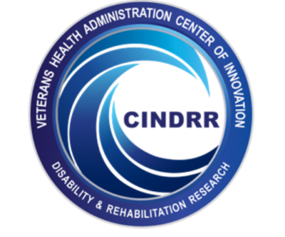
Department of Veterans Affairs
Fellowship Opportunities
HSR&D Center of Innovation on Disability and
Rehabilitation Research VISN 8 (CINDRR)

Focus Area #1: Postdoctoral Fellowship in Health Services
Research & Development in Rehabilitation Outcome
The purpose of this 2-year fellowship is to develop a cadre of scientists with health services expertise for the VA healthcare system and to foster the development of high quality health services research and development at local and national levels. The fellowship is located at the RR&D/HSR&D Center of Excellence in Rehabilitation Outcomes at the Tampa VA Hospital, Tampa, FL in collaboration with the VA HSR&D Service and partnership with the University of South Florida.

Focus Area #2: Interdisciplinary Fellowship in Patient Safety
The purpose of this 1-year fellowship program is to develop leaders with vision, knowledge, and commitment to lead patient safety efforts in the 21st century. The fellowship is located at the Patient Safety Center of Inquiry at the Tampa VA Hospital, Tampa, FL in collaboration with the VA National Center for Patient Safety and partnership with the University of South Florida.
Eligibility: Both—US citizenship and completion of all requirements need to be a fully credentialed independent practitioner in their field at a VA facility. Physicians must have graduated from an Accreditation Council for Graduate Medical Education (ACGME) accredited residency; be board certified or board eligible and have an active, unrestricted U. S. medical license. HSR&D Fellowship—PhD in their field. Patient Safety Fellowship—Clinical fields that recognize independent practitioners possessing degree levels below that of Master's Degree (e.g., Registered Nurse or Registered Dietician) must have completed a Master's Degree (or all requirements for the degree) to be eligible. Nurses, social workers, and health care administrators must possess at least a master's degree. Applicants in academic fields that do not involve clinical certification or licensure but that can be applicable to health systems (e.g. anthropology, sociology, computer science/medical informatics, engineering, etc.) must have received a PhD in their field.
Funding: Stipend rates are determined by VA Office of Academic Affiliations, depending on the discipline and previous education of the trainee. Fellows are eligible to participate in the Federal Employees Health Benefits Program and the Federal Employees Group Life Insurance Program.
Application and Start Dates: The deadline for application is February 1 for fellowships beginning July 1.
Application Process. Submission of an application that includes a letter, of no more than three pages, stating short and long term professional goals, clinical or other pertinent background, a statement of personal goals for the fellowship, a full curriculum vitae, and three letters of recommendation.
Applicants are strongly encouraged to talk to Dr. Powell-Cope before applying.
Selection and Selection Criteria. A selection committee will review and rank applications based on the following criteria: quality of credentials and experience, commitment to remain in the VA system, match between personal goals and planned program activities, and strength of recommendations.
For information about these and other fellowships in the VA you can check the VA's web page at: http://www.va.gov/oaa or the Center web page at http://www.rorc.research.va.gov or contact Dr. Gail Powell-Cope at gail.powell-cope@va.gov or call 813-558-3911.

