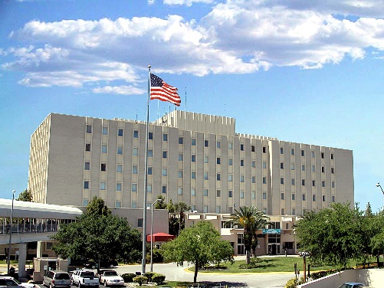
Advanced Fellowship in Patient Safety
Tampa VA Site
The purpose of this 1‐year fellowship program is to develop leaders with vision, knowledge, and commitment to lead patient safety efforts in the 21st century. The fellowship is located at the Patient Safety Center of Inquiry at James A. Haley Veterans’ Hospital, Tampa, FL in collaboration with the VA National Center for Patient Safety.

Eligibility:
- US citizenship and completion of all requirements needed to be a fully credentialed independent practitioner in their field at a VA facility.
- Physicians must have graduated from an Accreditation Council for Graduate Medical Education (ACGME) accredited residency; be board certified or board eligible, and have an active, unrestricted US medical license.
- Clinical fields that recognize independent practitioners possessing degree levels below that of a Master’s Degree (e.g. Registered Nurse or Registered Dietitian) must have completed a Master’s Degree (or all requirements for the degree) to be eligible. Nurses, social workers, and health care administrators must possess at least a Master’s Degree.
- Applicants in academic fields that do not involve clinical certification or licensure but that can be applicable to health systems (e.g. anpthropology, sociology, computer science/medical informatics, engineering, etc.) must have received a PhD in their field.
Funding: Funding stipend trainee rates are determined by VA Office of Academic Affiliations, depending on the discipline and previous education of the trainee (may be comparable to residency programs). Fellows may be eligible to participate in the Federal Employees Health Benefits Program and the Federal Employees Group Life Insurance Program, if they meet VA Human Resources eligibility requirements.

Application and Start Dates: The deadline for application is February 15 for fellowships beginning July 1.

Application Process: Submit an application that includes (a) a cover letter, of no more than three pages, stating short and long term professional goals, clinical or other pertinent background, and a statement of personal goals for the fellowship, (b) a full curriculum vitae, and (c) three letters of recommendation (signed). Application and letters can be emailed to yvonne.friedman@va.gov

Selection and Selection Criteria: A selection committee will review and rank applications based on the following criteria: quality of credentials and experience, commitment to remain in the VA system, match between personal goals and planned program activities, and strength of recommendations.

Additional Contact Info: Yvonne Friedman MA, OTR/L, yvonne.friedman@va.gov or Linda Cowan, PhD, Associate Director, VISN 8 Patient Safety Center of Inquiry, linda.cowan@va.gov.

