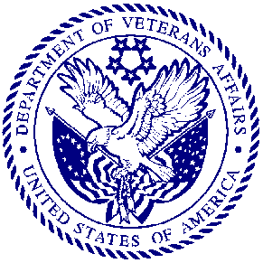
DEPARTMENT OF VETERANS AFFAIRS
Orlando VA Medical Center
5201 Raymond Street
Orlando, FL 32803

Documentation of English Language Proficiency In Reply Refer To: VA Handbook 5005/12

Today’s Date:

By signing this form, you are agreeing as a VHA Without Compensation (WOC) appointed trainee that you are proficient in basic written and spoken English. You are able to communicate in spoken and written English with patients and other health care personnel with sufficient fluency to satisfactorily carry out assigned responsibilities.

(VA Handbook 5005, Part II, Chapter 3, Section A, paragraph 3j)

Print Name/Program of Study Sign Name

